

GUJARAT TECHNOLOGICAL

UNIVERSITY

**Apollo Institute of Engineering**

**And**

**Technology**

**A Report on**

**Scrap Up Website**

**Under the subject**

**Project-1(3350706)**

**Submitted by**

**Enrollment No: - Name: -**

**204550307049 Adnan Kureshi**

**204550307006 Harsh Vyas**

**204550307031 Anish Karlekar**

**204550307014 Jay Sangani**

**Guided By**

**Prof. Richa Bhadauria**

**(Internal Guide)**

**Academic Year**

**(2022-23)**

**DEPARTMENT OF COMPUTER ENGINEERING**

# CERTIFICATE

This is to certify that the Project entitled **“SCRAPUP”** has been carried out by **Adnan Kureshi** bearing Enrollment Number **204550307049** under my guidance in the fulfilment for the degree of Diploma Engineering in Computer Engineering, 5th Semester of Gujarat Technological University, Ahmedabad during the academic year 2022-23.

**Date:**

**Place:**

**DEPARTMENT OF COMPUTER ENGINEERING**

# CERTIFICATE

This is to certify that the Project entitled **“SCRAPUP”** has been carried out by **Harsh Vyas** bearing Enrollment Number **204550307006** under my guidance in the fulfilment for the degree of Diploma Engineering in Computer Engineering, 5th Semester of Gujarat Technological University, Ahmedabad during the academic year 2022-23.

**Date:**

**Place:**

**DEPARTMENT OF COMPUTER ENGINEERING**

# CERTIFICATE

This is to certify that the Project entitled **“SCRAPUP”** has been carried out by **Anish Karlekar** bearing Enrollment Number **204550307031** under my guidance in the fulfilment for the degree of Diploma Engineering in Computer Engineering,5th Semester of Gujarat Technological University, Ahmedabad during the academic year 2022-23.

**Date:**

**Place:**



**DEPARTMENT OF COMPUTER ENGINEERING**

# CERTIFICATE

This is to certify that the Project entitled **“SCRAPUP”** has been carried out by **Jay Sangani** bearing Enrollment Number **204550307014** under my guidance in the fulfilment for the degree of Diploma Engineering in Computer Engineering ,5th Semester of Gujarat Technological University, Ahmedabad during the academic year 2022-23.

**Date:**

**Place:**

Prof. Richa Bhadauraia Mr. Prasant Patel

**Internal Guide Head of the Department**

## INDEX

**TOPICS PAGE NO.**

**INDEX i**

**LIST OF TABLES iii**

**LIST OF FIGURES iv**

**AKNOWLEDGEMENT v**

**ABSTRACT vi**

**CHAPTER 1: INTRODUCTION 1**

**1.1** Problem Summary  **1**

**1.2** Aim and Objectives of the project **1**

**1.3** Problem Specification **1**

**1.4** Brief Prior Art Search or Case Study **1**

**1.5** Plan of your work **1**

**1.6** Materials or Tool requirement **2**

**1.6.1** Hardware Requirement **2**

**1.6.2** Software requirement **2**

**CHAPTER 2: SYSTEM ANALYSIS**  **3**

**2.1** Study of existing system **3**

**2.2**  Proposed system  **3**

**2.2.1** Roles and responsibility of each module **3**

**2.3** Advantages of the purpose system  **5**

**2.4** Feasibility study **5**

**2.5** Requirements of New system **5**

**2.5.1** User Requirements **6**

**2.5.2** System Requirements **6**

**2.5.3** Functional Requirements **6**

**2.5.4** Non-functional Requirements **6**

**CHAPTER 3: SYSTEM DESIGN 8**

**3.1** Use Case diagram **8**

**3.2** Database design **12**

**3.2.1** Entity-Relationship diagram **13**

**3.2.2** Data dictionary **14**

**3.3** Activity diagram **17**

**3.4** Sequence diagram **21**

**CHAPTER 4: SYSTEM IMPLEMENTATION 24**

**4.1** Architectural design  **24**

**4.2** Development framework **26**

**4.3** Graphical User Interface (GUI) **27**

**CHAPTER 5: SUMMARY 30**

**REFERENCES 31**

### LIST OF TABLES

|  |  |  |
| --- | --- | --- |
| **Table. no** | **Table name** | **Pg no.** |
| **Table 3.2.2.1** | admin table | 15 |
| **Table 3.2.2.2** | Creator table | 16 |
| **Table 3.2.2.3** | User table | 16 |
| **Table 3.2.2.4** | Category table | 16 |
| **Table 3.2.2.5** | Order table | 17 |

#### LIST OF FIGURES

|  |  |  |
| --- | --- | --- |
| **Fig. no** | **Figure name** | **Pg no.** |
| **Fig. 1.5.1** | Gantt chart | 2 |
| **Fig. 3.1.1** | Use case diagram for admin | 9 |
| **Fig. 3.1.2** | Use case diagram for Creator | 10 |
| **Fig. 3.1.3** | Use case diagram for user | 11 |
| **Fig. 3.1.4** | System Use Case | 12 |
| **Fig. 3.2.1.1** | E R diagram | 14 |
| **Fig. 3.3.1** | Activity diagram for admin | 19 |
| **Fig. 3.3.2** | Activity diagram for Creator | 20 |
| **Fig. 3.3.3** | Activity diagram for user | 21 |
| **Fig. 3.4.1** | Sequence diagram for admin | 23 |
| **Fig. 4.1.1** | Iterative model | 24 |

## ACKNOLEDGEMENT

We have taken efforts in this project. However, it would not have been possible without the kind support and help of many individuals and organizations. We would like to extend our sincere thanks to all of them. It is our privilege to express our sincerest regards to our project coordinator, Ms. Richa Bhadauria for their valuable inputs, able guidance, encouragement, whole-hearted cooperation and constructive criticism throughout the duration of our project. We deeply express our sincere thanks to our Head of Department Mr. Prashant Patel for encouraging and allowing us to present the project. We take this opportunity to thank all our friends and colleagues who started us out on the topic and provided extremely useful review feedback and for their all-time support and help in each and every aspect of the course of our project preparation. We are grateful to our college Apollo Institute of Engineering and Technology, for providing us all required resources and good working environment.

### ABSTRACT

Scrap Up is an ecommerce resell platform focused on reducing the quantity of waste products or unrequired products by successfully promoting recycling of products no longer required for their prior use or by prior user.

We promote creativity, art and innovation through our special creator module which focuses on making sustainable products from unrequired products which can be reused for an entirely new purpose or for same purpose with better results. During which generating new employment opportunities and saving our home planet.

## CHAPTER 1 INTRODUCTION

### 1.1 PROBLEM SUMMARY

When someone wants to resell or recycle their products, the one who requires it or values it is hard to find, which leads to wastage of products and rising needs of those same products.

### 1.2 AIM AND OBJECTIVES OF THE PROJECT

We aim on finding buyers for sellers and vice versa, during which recycling products and providing employment via our special creator module.

### 1.3 PROBLEM SPECIFICATIONS

People get rid from there unwanted items by throwing them as waste, because they simply cannot find buyers for them. Some creators who can create better from worse remain unemployed due to lack of opportunities.

### 1.4 BRIEF PRIOR RESEARCH OR CASE STUDY

E-Bay: Unnecessary products are sold at high price due to bidding.

OLX: Only provides platform for selling old products.

Amazon: Only provides platform for selling new products and refurbished products only.

### 1.5 PLAN OF THE PROJECT

There are many factors to consider when it comes to composing a proper work plan ― goals, strategy, objectives, tactics, responsibilities, etc.

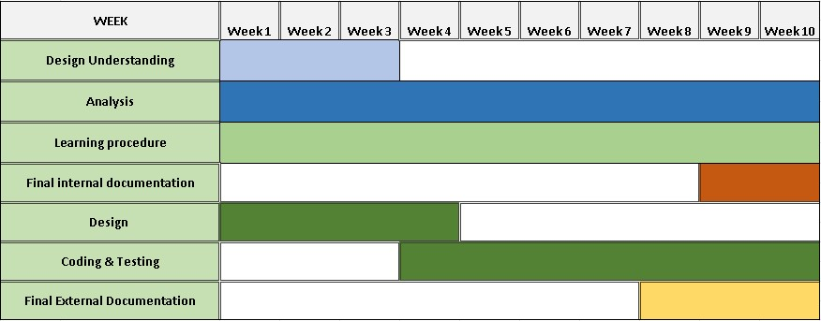

**Fig. 1.5.1 Gantt chart**

### 1.6 MATERIALS OR TOOLS REQUIRED

The basic requirement for developing website is shown below:

#### 1.6.1 Hardware requirements

RAM: minimum 4 GB

Processor: Intel i3 2nd gen/ AMD Ryzen 3200u or better

OS: WINDOWS XP or Equivalent

**1.6.2 Software requirements:**

Frontend:

* HTML
* CSS
* JAVASCRIPT
* BOOTSTRAP

Back-end:

* PHP
* MY SQL

**CHAPTER 2**

**SYSTEM ANALYSIS**

### 2.1 STUDY OF EXISTING SYSTEM

There are number of resell websites and e-commerce websites which sell products but they do not give special privileges of employment to creators who work hard and make an existing product better, there are some websites owned by creators to showcase their own products where one cannot sell their individual product.

### 2.2 PROPOSED SYSTEM

The driving force behind our project is our purpose to save earth from pollution caused due to waste products in the meantime providing employment to the creators.

#### 2.1.1 Roles and responsibilities of modules

The overall project module is divided into three parts. They are as shown below:

* Admin
* Buyer/Seller
* Creator

#### 2.2.1.1 ROLES OF ADMIN

* Registration
* Login
* Manage Buyer/Seller
* Manage Creator
* Manage Category
* Manage Products
* Manage Orders
* Manage Payments
* Manage Deliveries
* Logout

#### 2.2.1.2 ROLES OF BUYERS/SELLERS

* Registration
* Login
* Manage profile
* Sell/Buy Product
* Edit Products
* Remove Product
* Track Order
* Logout

#### 2.2.1.3 ROLES OF CREATOR

* Registration
* Login
* Manage Creator profile
* Manage Creator portfolio
* Sell/Buy Product
* Edit Products
* Remove Product
* Track Order
* Logout

### 2.3 ADVANTAGE OF THE PROPOSED SYSTEM

* Sustainable and eco-friendly products/services at affordable cost.

* Creating dignified employment for underprivileged skilled artisans.

* Contribute in waste management of India.

* Ethically handcrafted products at best prices.

* Enables the creators to give this creativity & innovation a shape, a platform.

### 2.4 FEASIBILITY STUDY

Feasibility Study in Software Engineering is a study to evaluate feasibility of proposed project or system. Feasibility study is one of stage among important four stages of Software Project Management Process.

As name suggests feasibility study is the feasibility analysis or it is a measure of the software product in terms of how much beneficial product development will be for the organization in a practical point of view. Feasibility study is carried out based on many purposes to analyze whether software product will be right in terms of development, implantation, contribution of project to the organization etc.

### 2.5 REQUIREMENTS OF NEW SYSTEM

### 

* The purpose of the system is to develop website that can help and reduce the search of buyers for the products and providing creators an easy to access platform.

**2.5.1 User requirements**

* Recyclable products and eco-friendly handcrafted products to sell.

#### 2.5.2 System requirements

* Front end: CSS, HTML JAVASCRIPT
* Back end: MYSQL, PHP
* Other tools: MS office

#### 2.5.3 Functional requirements

These are the requirements that the end user specifically demands as basic facilities that the system should offer. All these functionalities need to be necessarily incorporated into the system as a part of the contract.

* Password Hashing
* Payment Interface
* Secure Database
* Mobile-Friendliness
* Ease of access
* Payment History
* Filters
* Grand Total Calculator

#### 2.5.4 Non-functional requirements

Non-functional requirements describe how the system works. A non-functional requirement is a requirement that specifies criteria that can be used to judge the operation of a system, rather than specific behaviors.

1. **Security:** 
   * + Only authorized person can view and modify confidential details.
     + Each user has his/her own access rights and lower-level user here have restrictions of using some of the system components.
     + One user can’t access other user’s account or information.
2. **Privacy:**

• Any person will be not able to change or modify information from

application. It is only altered by admin.

1. **Scalability:** 
   * Performance of the system should not be degraded when many customers are logged in and accessing the database at the same time.
   * The system must be scalable enough to be able to add any additional functionality even after the project is developed once.
2. **Reliability:** 
   * The database of various modules like users, Arts maintained by system should be correct maintained up to date.

## CHAPTER 3 SYSTEM DESIGN

### 3.1 USE CASE DIAGRAM

Use Case Diagram Displays the relationship among actors and use cases. A use case diagram shows a set of use cases and actors (a special kind of class) and their relationships. Use case diagrams address the static use case view of a system. These diagrams are especially important in organizing and modelling the behaviors of a system.

#### Table 3.1.1 Use Case Symbol

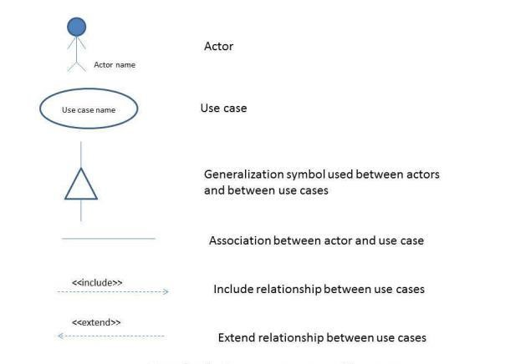

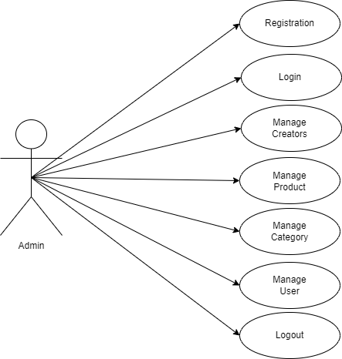

Fig. 3.1.1 Use case diagram for admin

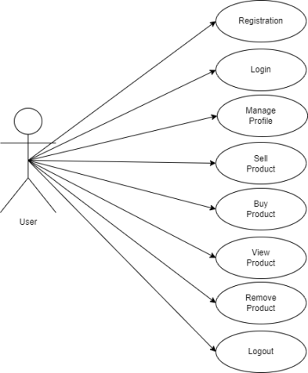 Fig. 3.1.2 Use case diagram for User

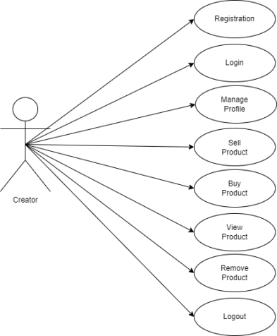

#### Fig. 3.1.3 Use case diagram for Creator

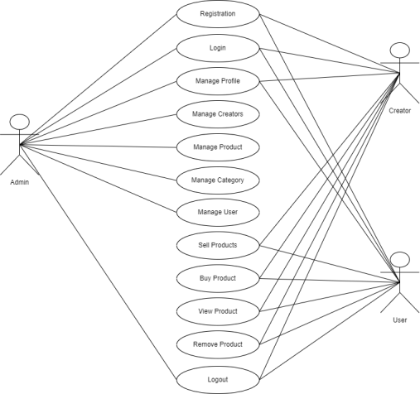

Fig 3.1.4: System Use Case

### 3.2 DATABASE DESIGN

Database design is the process of producing a detailed data model of the database. This data model contains all the needed logical and physical design choices and physical storage parameters needed to generate a design in a data definition language, which can be used to create a database.

The main objectives of database deigning are to produce logical and physical designs model of the proposed database system. . The logical model concentrates on the data requirements and the data to be stored independent of physical considerations. It does not concern itself with how the data will be stored or where it will be stored physically. The physical data design model involves translating the logical design of the database onto physical media using hardware resources and software systems such as database management systems (DBMS).

#### 3.2.1 Entity Relationship (ER) diagram

Entity relationship is described by their dependence on each other, as well as by extent of the relationship.

We will begin by examining the basis of database management drawing on the relationship among data and the sharing of data across different application.

Entity relationship analysis uses three major abstractions to described data.

1. Entities: - Entities are distinguishable object that can be represented in the database.
2. Relationship: - It is meaningful interaction between the entities.
3. Attributes: - It is nothing but properties of entities.
4. In E-R Diagram three types of Relationship exists: -
5. One-to-One (1:1): - Relationship is associated between two objects.
6. One-to-Many (1: M or M: 1): - Relationship describes an entity that may more Entities related to it.
7. Many-to-Many (M: M): - Relationship describes an entities multiple relationship with other entities.

E-R diagram contains following components:

1. Rectangle: This represents entity sets.
2. Ellipse: This represents attributes.

1. Diamonds: This represents relationship sets.
2. Line: Which links attributes to entity sets and entity sets to relationship sets.

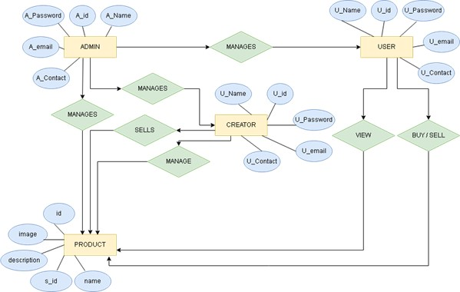

#### Fig. 3.2.1.1 E R diagram

##### 3.2.2 Data Dictionary

A Data Dictionary is Catalogue-Responsibility of the Element in a System. As the Name Suggests, these Element are Structured around Data in a Way to Meet the Use and the Organization Requirements. A Data Dictionary is a List of Elements that composes all the Data Flow Process through the System. It stores detail and description of data flow, data store and processes.

If analysts want to know by what other means is a table or a data item referenced in the system or where it is being used the answers are properly developed in the data dictionary. The dictionary id developed during data flow analysis and assists the analysts involved in requirements. However, its content is used during system design as well.

**3.2.2.1 Feature of Data Dictionary**

The volume of data in most information system is substantial more than a single analyst can easily keep track of the same. When the teams of analyst work on assistance the task of co-coordinating data definition becomes more complex. Individual depends on the information provided by others with their assumption and the specification made by them.

Data dictionary is integral component of structured analysis. Since dataflow diagram by them do not fully describe the subject of the investigation. The data dictionary provides additional information about system.

###### Table 3.2.2.1: admin table

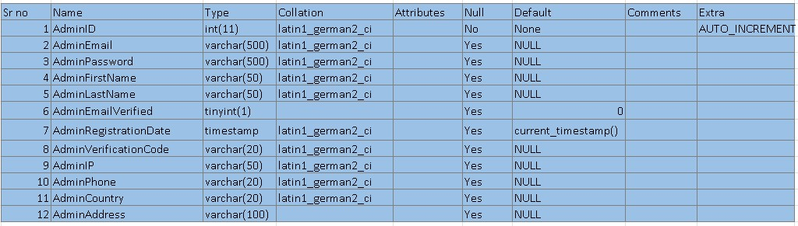

###### Table 3.2.2.2: Creator table

###### Table 3.2.2.3: User table

###### Table 3.2.2.4: Category table

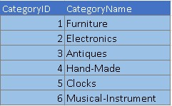

###### 

###### Table 3.2.2.5: Order table

### 3.3 ACTIVITY DIAGRAM

Activity diagrams are one of the five diagrams in the UML for modelling the dynamic aspects of systems.

An activity diagram is essentially a flowchart, showing flow of control from activity to activity. We use activity diagrams to model the dynamic aspects of a system. For the most part, this involves modelling the sequential (and possibly concurrent) steps in a computational process.

With an activity diagram, you can also model the flow of an object as it moves from state to state at different points in the flow of control. Activity diagrams may stand alone to visualize, specify, construct, and document the dynamics of a society of objects, or they may be used to model the flow of control of an operation. Whereas interaction diagrams emphasize the flow of control from object to object, activity diagrams emphasize the flow of control from activity to activity.

An activity is an ongoing non atomic execution within a state machine. Activities ultimately result in some action, which is made up of executable atomic computations those results in a change in state of the system or the return of a value. Activity diagrams are not only important for modelling the dynamic aspects of a system, but also for constructing executable systems through forward and reverse engineering.

Table: 3.3.1 Activity Diagram Symbols

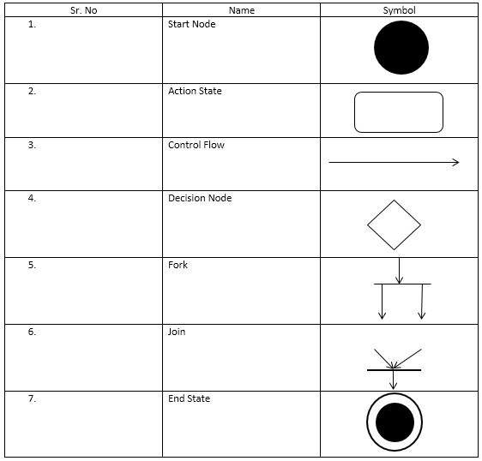

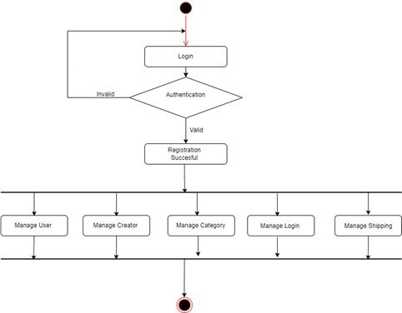

Fig. 3.3.1 Activity diagram for admin

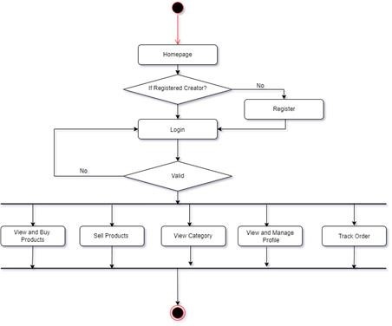

Fig 3.3.2 Activity diagram for creator

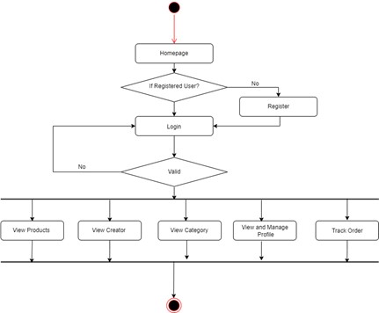

Fig. 3.3.3 Activity diagram for user

### 3.4 SEQUENCE DIAGRAM

A sequence diagram emphasizes the time ordering of messages. We form a sequence diagram by first placing the objects that participate in the interaction at the top of your diagram, across the X axis. Typically, you place the object that initiates the interaction at the left, and increasingly more subordinate objects to the right. Next, you place the messages that these objects send and receive along the Y axis, in order of increasing time from top to bottom. This gives the reader a clear visual cue to the flow of control over time.

#### Table: 3.4.1 Sequence Diagram Symbols

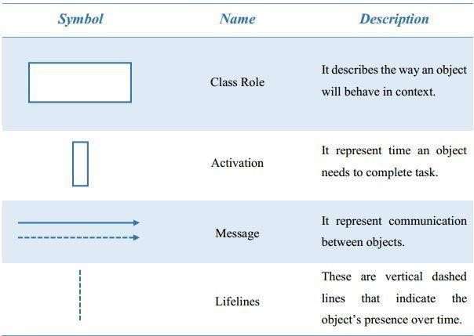

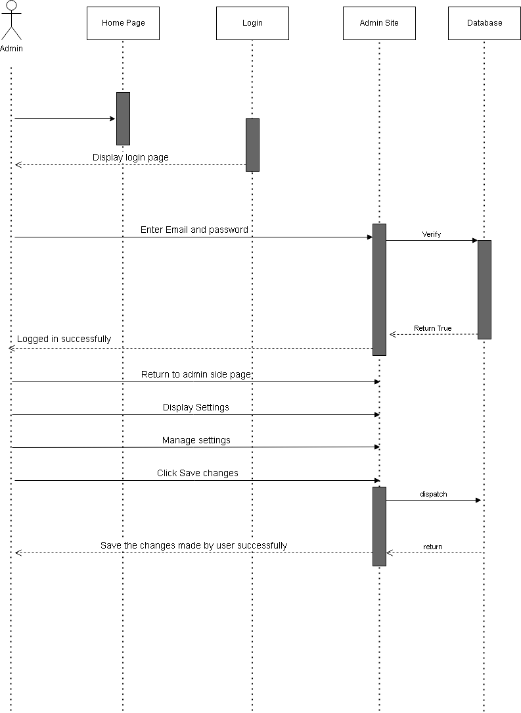

Fig. 3.4.1 Sequence diagram for Admin

## CHAPTER 4

## SYSTEM IMPLEMENTATION

### 4.1 Process Model

Iterative process starts with a simple implementation of a subset of the software requirements and iteratively enhances the evolving versions until the full system is implemented. At each iteration, design modifications are made and new functional capabilities are added. The basic idea behind this method is to develop a system through repeated cycles (iterative) and in smaller portions at a time (incremental).

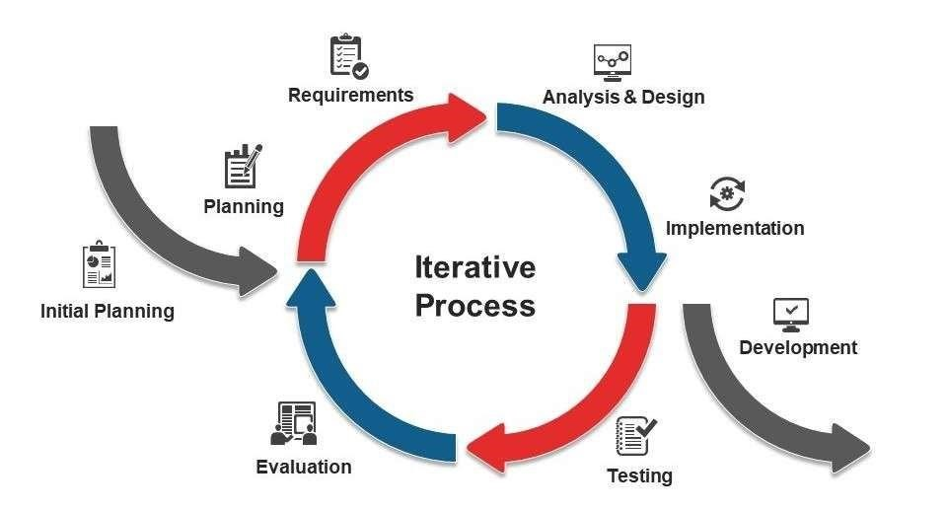

### Fig .4.1.1 Iterative Model

Consider an iterative life cycle model which consists of repeating the following four phases in sequence: Requirements Phase: In the requirements phase of software development, the system related information is gathered and analyzed. The collected requirements are then planned accordingly for developing the system.

Design Phase: In the Design phase, the software solution is prepared to meet the necessities for the design. The system design may be a new one or the extension of a previous build one. Implementation and Test: In the implementation as well as a test phase, the system is developed by coding and building the user interface and modules which is then incorporated and tested.

Review Phase: The review phase is where the software is estimated and checked as per the current requirement. Then, further requirements are reviewed, discussed and reviewed to propose for an update in the next iteration. Iterative model is used in the following purposes:

* Here, the system requirements can be classified and understood.
* Primary necessities of the system can be defined; at the same time, some system's working can be improved with the development process.
* If a new technology needs prior understanding, this model can be helpful to know the latest technology and increment or update the model accordingly.
* This model is also useful when there are high risks in the system characteristic and goals.
* Situations where resources with required skill sets are not accessible, and the system needs to be developed on a contract basis, choosing this model is a suitable decision. Advantages of Iterative Model
* Produces working system rapidly and before time throughout the software development life cycle.
* Provides more and more flexible and enhance based on requirements.
* Simple to test as well as repair as small iteration.

### 4.2 DEVELOPMENT FRAMEWORK

**PHP:**

* PHP personal Home Page

* PHP is an acronym for "PHP: **Hypertext Preprocessor"**

* PHP invent in 1994 by Rasmus Lerdorf.

* PHP is a widely-used, open-source server-side scripting language

* PHP can generate dynamic page content.

* PHP is a powerful tool for making dynamic and interactive Web pages.

* PHP scripts are executed on the server.

* PHP is free to download and use.

* PHP files can contain text, HTML, CSS, JavaScript, and PHP code.

* PHP files have extension ".php".

**What is new in PHP 7?**

* PHP 7 is much faster than the previous popular stable release (PHP 5.6).

* PHP 7 has improved Error Handling.

* PHP 7 supports stricter Type Declarations for function arguments.

* PHP 7 supports new operators (like the spaceship operator: <=>)

**2) PHP features?**

* Simple

* Interpreted

* Faster

* Open Source

* Platform Independent

* Case Sensitive

* Speed Comparison of ASP PHP JSP

* Simplicity

* More frameworks & CMS

#### 4.3 GRAPHICAL USER INTERFACE (GUI)

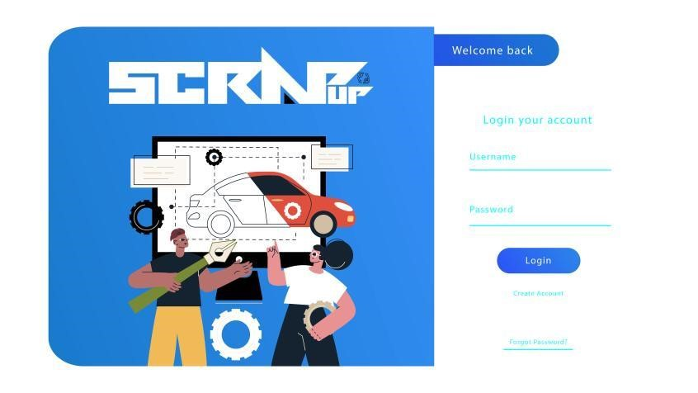

Fig. 4.3.1 Login

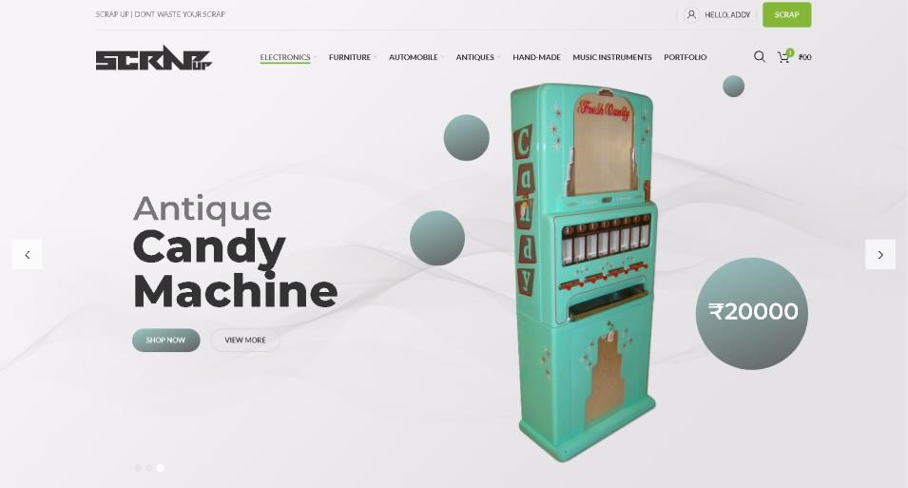

#### Fig. 4.3.2 Home Page

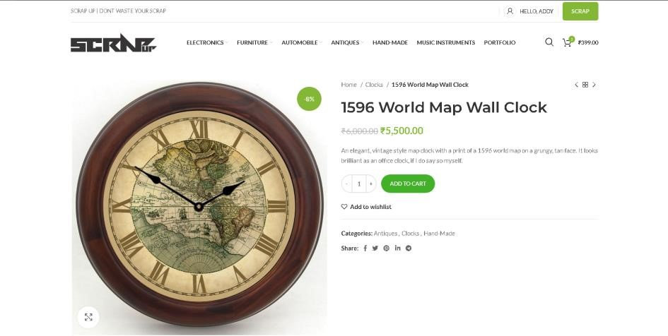

#### Fig 4.3.3: Product Page

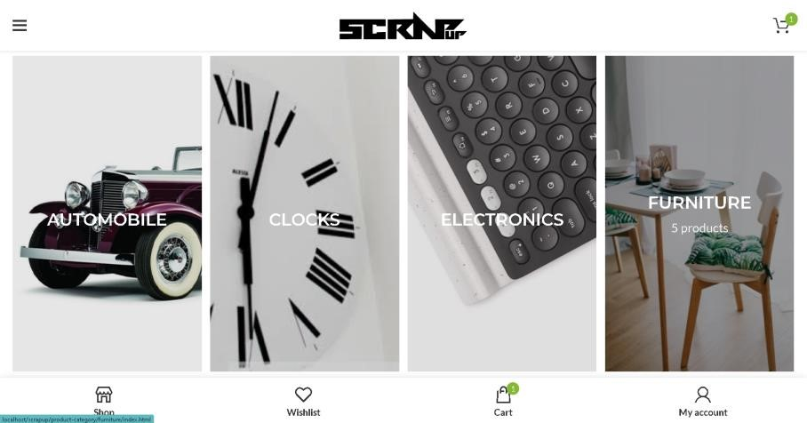

**Fig 4.3.4: Category Section**

## CHAPTER 5

## SUMMARY

Scrap Up is an emerging ecommerce website specifically made for reselling products that are no longer required by their previous owner and are waste for them, by reselling Scrap Up provides an efficient way of waste management and contributes to sustainable development.

Scrap Up’s USP is special creator module that boosts employment opportunities to make old products that are to be resell, better for future scope of usage through help of creative individuals working on their own or for the Scrap Up

**Reference**

### WEBSITES

1. **For Php Tutorial:**

[**https://www.w3schools.com/php**](https://www.w3schools.com/php)[**/**](https://www.w3schools.com/php/)

1. **For HTML Tutorial:**

[**https://www.w3schools.com/html**](https://www.w3schools.com/html)[**/**](https://www.w3schools.com/html/)

1. **For CSS:**

[**https://www.w3schools.com/w3css/defaulT.as**](https://www.w3schools.com/w3css/defaulT.as)[**p**](https://www.w3schools.com/w3css/defaulT.asp)

1. **OLX**

https://www.olx.in

1. **Amazon**

[**https://www.amazon.in**](https://www.amazon.in)

1. [**F**](https://www.arjunkarthaphotography.com/)**lipkart**

https://www.flipkart.in

1. **Ebay**

[**https://www.ebay.com/**](https://www.ebay.com/)